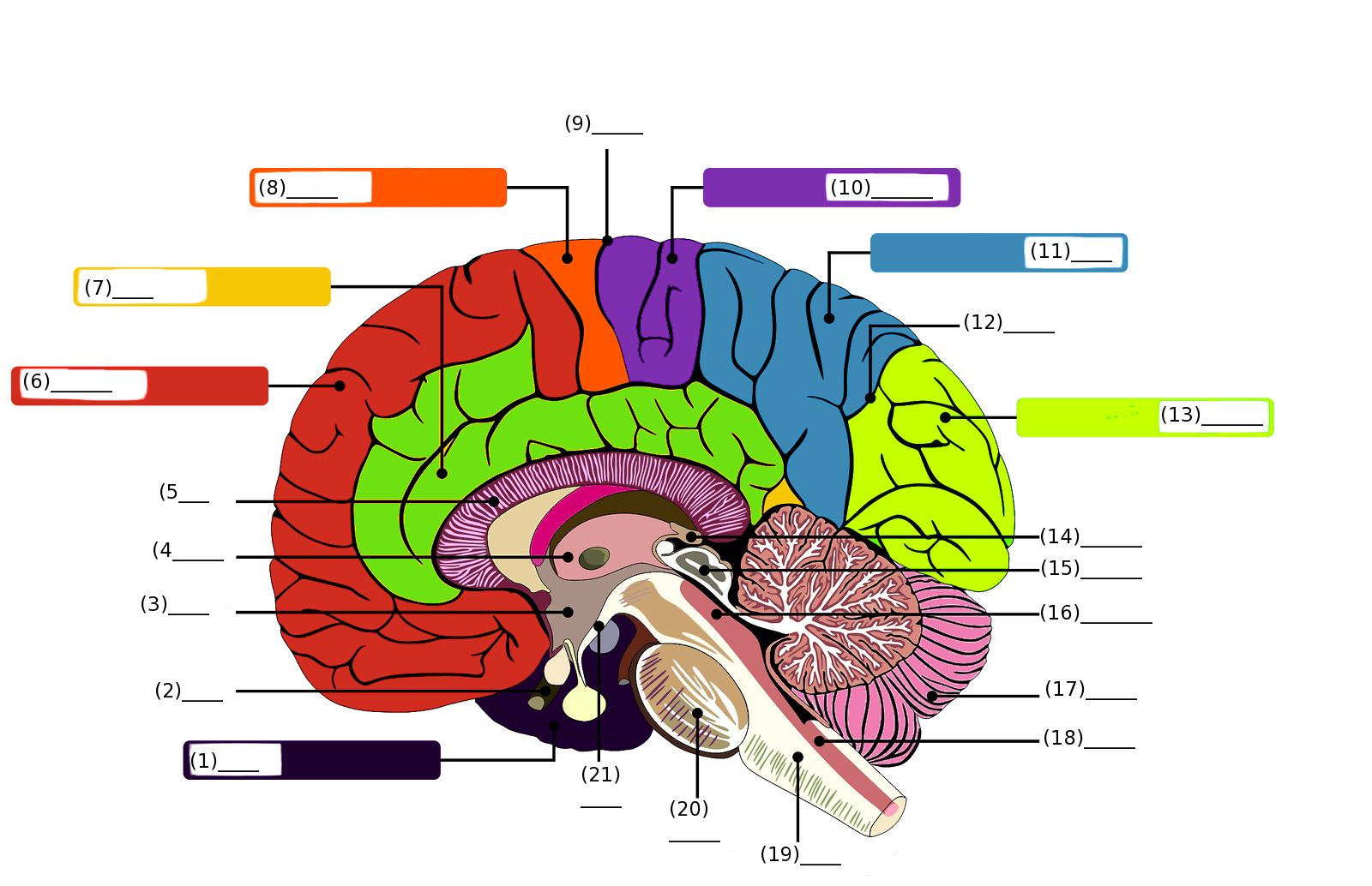**Midsagittal Cut of the Brain Labeling Activity**

**Word Bank**

1. Thalamus
2. Temporal Lobe
3. Precentral Gyrus
4. Postcentral Gyrus
5. Pons
6. Pineal Gland
7. Parieto-occipital Suculus
8. Parietal Lobe
9. Optic Chiasm
10. Occipital Lobe
11. Medulla Oblongata
12. Maximillary Body
13. Limbic Lobe
14. Hypothalamus
15. Frontal Lobe
16. Fourth Ventricle
17. Corpus Callosum
18. Corpora Quadrigemina
19. Cerebellum
20. Central Suculus
21. Aqueduct of the Midbrain

**Answer Key**

1. Temporal Lobe
2. Optic Chasm
3. Hypothalamus
4. Thalamus
5. Corpus Callosum
6. Frontal Lobe
7. Limbic Lobe
8. Precentral Gyrus
9. Central Suculus
10. Postcentral Gyrus
11. Parietal Lobe
12. Parieto-occipital Suculus
13. Occipital Lobe
14. Pineal Gland
15. Corpora Quadrigemina
16. Aqueduct of the Midbrain
17. Cerebellum
18. Fourth Ventricle
19. Medulla Oblongata
20. Pons
21. Maximillary Body